***Sec. 2-1 (p.51)***

|  |  |  |  |  |  |  |  |  |  |  |  |  |  |  |  |  |  |  |  |  |  |  |  |  |  |  |  |  |  |  |  |  |  |  |  |  |  |  |  |  |  |  |  |  |  |  |  |  |  |  |  |
| --- | --- | --- | --- | --- | --- | --- | --- | --- | --- | --- | --- | --- | --- | --- | --- | --- | --- | --- | --- | --- | --- | --- | --- | --- | --- | --- | --- | --- | --- | --- | --- | --- | --- | --- | --- | --- | --- | --- | --- | --- | --- | --- | --- | --- | --- | --- | --- | --- | --- | --- | --- |
| **13.** | **Favorite Coffee Flavor**  A survey was taken asking the favorite flavor of a coffee drink a person prefers. The responses were V = Vanilla (香草), C = Caramel (焦糖), M= Mocha (摩卡), H = Hazelnut (榛果), and P = Plain (純). Construct a categorical frequency distribution for the data. Which class has the most data values and which class has the fewest data  values?   |  |  |  |  |  |  |  |  |  |  | | --- | --- | --- | --- | --- | --- | --- | --- | --- | --- | | V | C | P | P | M | M | P | P | M | C | | M | M | V | M | M | M | V | M | M | M | | P | V | C | M | V | M | C | P | M | P | | M | M | M | P | M | M | C | V | M | C | | C | P | M | P | M | H | H | P | H | P | |

|  |  |  |  |
| --- | --- | --- | --- |
| 1  Class | 2  Tally (紀錄) | 3  Frequency | 4  Percent = $\frac{freq}{total}$ |
| V | ~~////~~ / | 6 | 12% |
| C | ~~////~~ // | 7 | 14% |
| M | ~~////~~ ~~////~~ ~~////~~ ~~////~~ // | 22 | 44% |
| H | /// | 3 | 6% |
| P | ~~////~~ ~~////~~ // | 12 | 24% |
|  |  | Total = 50 | 100% |

The class of mocha has the most data values, the class of hazelnut has the fewest data values.

|  |  |  |  |  |  |  |  |  |  |  |  |  |  |  |  |  |  |  |  |  |  |  |  |  |  |  |  |  |  |  |  |  |  |  |  |  |  |  |  |  |  |  |  |  |  |  |  |  |  |  |  |
| --- | --- | --- | --- | --- | --- | --- | --- | --- | --- | --- | --- | --- | --- | --- | --- | --- | --- | --- | --- | --- | --- | --- | --- | --- | --- | --- | --- | --- | --- | --- | --- | --- | --- | --- | --- | --- | --- | --- | --- | --- | --- | --- | --- | --- | --- | --- | --- | --- | --- | --- | --- |
| **15.** | **Eating at Fast Food Restaurants**  A survey was taken of 50 individuals. They were asked how many days per week they ate at a fast-food classes restaurant. Construct a the frequency distribution using 8 classes (0-7). Based on the distribution, how often did most people eat at a fastfood restaurant?   |  |  |  |  |  | | --- | --- | --- | --- | --- | | 1 | 3 | 4 | 0 | 4 | | 5 | 2 | 2 | 3 | 1 | | 2 | 2 | 2 | 2 | 2 | | 2 | 2 | 2 | 2 | 3 | | 2 | 2 | 5 | 2 | 4 | | 2 | 4 | 5 | 2 | 1 | | 4 | 1 | 3 | 2 | 2 | | 2 | 0 | 7 | 2 | 3 | | 2 | 2 | 2 | 5 | 2 | | 3 | 3 | 4 | 1 | 3 | |

|  |  |  |  |
| --- | --- | --- | --- |
| 1  Class | 2  Tally (紀錄) | 3  Frequency | 4  Percent = $\frac{freq}{total}$ |
| 0 | // | 2 | 4% |
| 1 | ~~////~~ | 5 | 10% |
| 2 | ~~////~~ ~~////~~ ~~////~~ ~~////~~ //// | 24 | 48% |
| 3 | ~~////~~ /// | 8 | 16% |
| 4 | ~~////~~ / | 6 | 12% |
| 5 | //// | 4 | 8% |
| 6 |  | 0 | 0% |
| 7 | / | 1 | 2% |
|  |  | Total = 50 | 100% |

The category “twice a week” has more values than any other category.

|  |  |  |  |  |  |  |  |  |  |  |  |  |  |  |  |  |  |  |  |  |  |  |  |  |  |  |  |  |  |  |  |  |  |  |  |  |  |  |  |  |  |
| --- | --- | --- | --- | --- | --- | --- | --- | --- | --- | --- | --- | --- | --- | --- | --- | --- | --- | --- | --- | --- | --- | --- | --- | --- | --- | --- | --- | --- | --- | --- | --- | --- | --- | --- | --- | --- | --- | --- | --- | --- | --- |
| **17.** | **Maximum Wind Speeds**  The data show the maximum wind speeds in miles (英里) per hour recorded for 40 states.  Construct a frequency distribution using 7 classes.   |  |  |  |  |  | | --- | --- | --- | --- | --- | | 59 | 78 | 62 | 72 | 67 | | 76 | 92 | 77 | 64 | 83 | | 64 | 70 | 67 | 75 | 75 | | 78 | 75 | 71 | 72 | 93 | | 68 | 69 | 76 | 72 | 85 | | 64 | 70 | 77 | 74 | 72 | | 53 | 67 | 48 | 76 | 59 | | 87 | 53 | 77 | 70 | 63 | |

$L=48$, $H=93$ $→$ $R=H-L=45$ $→$ $Width=\frac{45}{7}=6.43$ round up to 7

|  |  |  |  |  |  |
| --- | --- | --- | --- | --- | --- |
| 1  Class limits | | 2  Boundaries | | 3  Tally (紀錄) | 4  Frequency |
| lower limits | upper limits | lower boundary =  lower limits – 0.5 | upper boundary =  upper limits + 0.5 |
| 48 | 54 | 47.5 | 54.5 | /// | 3 |
| 55 | 61 | 54.5 | 61.5 | // | 2 |
| 62 | 68 | 61.5 | 68.5 | ~~////~~ //// | 9 |
| 69 | 75 | 68.5 | 75.5 | ~~////~~ ~~////~~ /// | 13 |
| 76 | 82 | 75.5 | 82.5 | ~~////~~ /// | 8 |
| 83 | 89 | 82.5 | 89.5 | /// | 3 |
| 90 | 96 | 89.5 | 96.5 | // | 2 |
|  | |  | |  | Total = 40 |

|  |  |  |
| --- | --- | --- |
|  | | cumulative freq. |
| less than | 47.5 | 0 |
| less than | 54.5 | 0 + 3 = 3 |
| less than | 61.5 | 3 + 2 = 5 |
| less than | 68.5 | 5 + 9 = 14 |
| less than | 75.5 | 14 + 13 = 27 |
| less than | 82.5 | 27 + 8 = 35 |
| less than | 89.5 | 35 + 3 = 38 |
| less than | 96.5 | 38 + 2 = 40 |

|  |  |  |  |  |  |  |  |  |  |  |  |  |  |  |  |  |  |  |  |  |  |  |  |  |  |  |  |  |  |  |  |  |  |  |  |  |
| --- | --- | --- | --- | --- | --- | --- | --- | --- | --- | --- | --- | --- | --- | --- | --- | --- | --- | --- | --- | --- | --- | --- | --- | --- | --- | --- | --- | --- | --- | --- | --- | --- | --- | --- | --- | --- |
| **20.** | **Salaries of Governors**  Here are the salaries (in dollars) of the governors (州長) of 25 randomly selected states. Construct a grouped frequency distribution with 6 classes.   |  |  |  |  |  |  |  | | --- | --- | --- | --- | --- | --- | --- | |  | 112,895 | 117,312 | 140,533 | 110,000 | 115,311 |  | |  | 95,000 | 177,500 | 120,303 | 139,590 | 150,000 |  | |  | 173,987 | 130,000 | 133,821 | 144,269 | 142,542 |  | |  | 150,000 | 145,885 | 105,000 | 93,600 | 166,891 |  | |  | 130,273 | 70,000 | 113,834 | 117,817 | 137,092 |  | |

$L=70,000$, $H=177,500$ $→$ $R=H-L=107,500$ $→$ $Width=\frac{107,500}{6}=17,916.67$ round up to 17,917

|  |  |  |  |  |  |
| --- | --- | --- | --- | --- | --- |
| 1  Class limits | | 2  Boundaries | | 3  Tally (紀錄) | 4  Frequency |
| lower limits | upper limits | lower boundary =  lower limits – 0.5 | upper boundary =  upper limits + 0.5 |
| 70,000 | 87,916 | 69,999.5 | 87,916.5 | / | 1 |
| 87,917 | 105,833 | 87,916.5 | 105,833.5 | /// | 3 |
| 105,834 | 123,750 | 105,833.5 | 123,750.5 | ~~////~~ // | 7 |
| 123,751 | 141,667 | 123,750.5 | 141,667.5 | ~~////~~ / | 6 |
| 141,668 | 159,584 | 141,667.5 | 159,584.5 | ~~////~~ | 5 |
| 159,585 | 177,501 | 159,584.5 | 177,501.5 | /// | 3 |
|  | |  | |  | Total = 25 |

|  |  |  |
| --- | --- | --- |
|  | | cumulative freq. |
| less than | 69,999.5 | 0 |
| less than | 87,916.5 | 1 |
| less than | 105,833.5 | 4 |
| less than | 123,750.5 | 11 |
| less than | 141,667.5 | 17 |
| less than | 159,584.5 | 22 |
| less than | 177,501.5 | 25 |

***Sec. 2-2 (p.65)***

|  |  |  |  |  |  |  |  |  |  |  |  |  |  |  |  |  |  |  |  |  |  |  |  |  |  |  |  |  |  |  |  |  |  |  |  |  |  |  |  |  |  |  |  |  |  |  |  |  |  |  |  |
| --- | --- | --- | --- | --- | --- | --- | --- | --- | --- | --- | --- | --- | --- | --- | --- | --- | --- | --- | --- | --- | --- | --- | --- | --- | --- | --- | --- | --- | --- | --- | --- | --- | --- | --- | --- | --- | --- | --- | --- | --- | --- | --- | --- | --- | --- | --- | --- | --- | --- | --- | --- |
| **3.** | **Pupils Per Teacher**  The average number of pupils (學生) per teacher in each state is shown. Construct a grouped frequency distribution with 6 classes. Draw a histogram, frequency polygon, and ogive. Analyze the distribution.   |  |  |  |  |  | | --- | --- | --- | --- | --- | | 16 | 16 | 15 | 12 | 14 | | 13 | 16 | 14 | 15 | 14 | | 18 | 18 | 18 | 12 | 15 | | 15 | 16 | 16 | 15 | 15 | | 25 | 19 | 15 | 12 | 22 | | 18 | 14 | 13 | 17 | 9 | | 13 | 14 | 13 | 16 | 12 | | 14 | 16 | 10 | 22 | 20 | | 12 | 14 | 18 | 15 | 14 | | 16 | 12 | 12 | 13 | 15 | |

$L=9$, $H=25$ $→$ $R=H-L=16$ $→$ $Width=\frac{16}{6}=2.67$ round up to 3

|  |  |  |  |  |  |
| --- | --- | --- | --- | --- | --- |
| Class limits | | Boundaries | | Midpoints = $$\frac{upper boundary+ lower boundary}{2}$$ | Frequency |
| lower limits | upper limits | lower boundary | upper boundary |
| 9 | 11 | 8.5 | 11.5 | 10 | 2 |
| 12 | 14 | 11.5 | 14.5 | 13 | 20 |
| 15 | 17 | 14.5 | 17.5 | 16 | 18 |
| 18 | 20 | 17.5 | 20.5 | 19 | 7 |
| 21 | 23 | 20.5 | 23.5 | 22 | 2 |
| 24 | 26 | 23.5 | 26.5 | 25 | 1 |
|  | |  | |  | Total = 50 |

|  |  |  |
| --- | --- | --- |
|  | | cumulative freq. |
| less than | 8.5 | 0 |
| less than | 11.5 | 2 |
| less than | 14.5 | 22 |
| less than | 17.5 | 40 |
| less than | 20.5 | 47 |
| less than | 23.5 | 49 |
| less than | 26.5 | 50 |

|  |  |
| --- | --- |
| histogram | freq. polygon |
|  |  |
| ogive | |
|  | |

The distribution is positively / right skewed with a peak at the class of 11.5 – 14.5.

|  |  |  |  |  |  |  |  |  |  |  |  |  |  |  |  |  |  |  |  |  |  |
| --- | --- | --- | --- | --- | --- | --- | --- | --- | --- | --- | --- | --- | --- | --- | --- | --- | --- | --- | --- | --- | --- |
| **5.** | **Railroad Crossing Accidents**  The data show the number of railroad crossing (路口) accidents for the 50 states of the United States for a specific year. Construct a histogram, frequency polygon, and ogive for the data. Comment on the skewness of the distribution.   |  |  | | --- | --- | | **Class limits** | **Frequency** | | 1 – 43 | 24 | | 44 – 86 | 17 | | 87 – 129 | 3 | | 130 – 172 | 4 | | 173 – 215 | 1 | | 216 – 258 | 0 | | 259 – 301 | 0 | | 302 – 344 | 1 | |  | Total 50 | |

|  |  |  |  |
| --- | --- | --- | --- |
| Boundaries | | Midpoints | Frequency |
| lower boundary | upper boundary |
| 0.5 | 43.5 | 22 | 24 |
| 43.5 | 86.5 | 65 | 17 |
| 86.5 | 129.5 | 108 | 3 |
| 129.5 | 172.5 | 151 | 4 |
| 172.5 | 215.5 | 194 | 1 |
| 215.5 | 258.5 | 237 | 0 |
| 258.5 | 301.5 | 280 | 0 |
| 301.5 | 344.5 | 323 | 1 |
|  | |  | Total = 50 |

|  |  |  |
| --- | --- | --- |
|  | | cumulative freq. |
| less than | 0.5 | 0 |
| less than | 43.5 | 24 |
| less than | 86.5 | 41 |
| less than | 129.5 | 44 |
| less than | 172.5 | 48 |
| less than | 215.5 | 49 |
| less than | 258.5 | 49 |
| less than | 301.5 | 49 |
| less than | 344.5 | 50 |

|  |  |
| --- | --- |
| histogram | freq. polygon |
|  |  |
| ogive | |
|  | |

The distribution is positively / right skewed.

|  |  |  |  |  |  |  |  |  |  |  |  |  |  |  |  |  |  |  |  |  |  |  |  |  |  |
| --- | --- | --- | --- | --- | --- | --- | --- | --- | --- | --- | --- | --- | --- | --- | --- | --- | --- | --- | --- | --- | --- | --- | --- | --- | --- |
| **10.** | **Making the Grade**  The frequency distributions shown indicate the percentages of public school students in fourth-grade reading and mathematics who performed at or above the required proficiency levels (熟練度) for the 50 states in the United States. Draw histograms for each, and decide if there is any difference in the performance of the students in the subjects.   |  |  |  | | --- | --- | --- | | **Class** | **Reading**  **frequency** | **Math**  **frequency** | | 17.5 – 22.5 | 7 | 5 | | 22.5 – 27.5 | 6 | 9 | | 27.5 – 32.5 | 14 | 11 | | 32.5 – 37.5 | 19 | 16 | | 37.5 – 42.5 | 3 | 8 | | 42.5 – 47.5 | 1 | 1 | |  | Total 50 | Total 50 | |

|  |  |
| --- | --- |
| histogram of reading | histogram of math |
|  |  |

The distribution of math percentages is more bell-shaped than the distribution of reading percentages, and its peak in the class of 32.5 – 37.5 is not as high as the peak of the reading percentage.

|  |  |  |  |  |  |  |  |  |  |  |  |  |  |  |  |  |  |  |  |  |  |  |  |  |  |  |  |  |  |  |  |  |  |  |  |  |  |  |  |  |  |
| --- | --- | --- | --- | --- | --- | --- | --- | --- | --- | --- | --- | --- | --- | --- | --- | --- | --- | --- | --- | --- | --- | --- | --- | --- | --- | --- | --- | --- | --- | --- | --- | --- | --- | --- | --- | --- | --- | --- | --- | --- | --- |
| **18.** | **Protein** (蛋白質) **Grams in Fast Food**  The amount of protein (in grams) for a variety of (各種) fast-food sandwiches is reported here. Construct a frequency distribution, using 6 classes. Draw a histogram, a frequency polygon, and an ogive for the data, using relative frequencies. Describe the shape of the histogram.   |  |  |  |  |  |  |  |  |  |  | | --- | --- | --- | --- | --- | --- | --- | --- | --- | --- | | 23 | 30 | 20 | 27 | 44 | 26 | 35 | 20 | 29 | 29 | | 25 | 15 | 18 | 27 | 19 | 22 | 12 | 26 | 34 | 15 | | 27 | 35 | 26 | 43 | 35 | 14 | 24 | 12 | 23 | 31 | | 40 | 35 | 38 | 57 | 22 | 42 | 24 | 21 | 27 | 33 | |

$L=12$, $H=57$ $→$ $R=H-L=45$ $→$ $Width=\frac{45}{6}=7.5$ round up to 8

|  |  |  |  |  |  |  |  |  |  |  |
| --- | --- | --- | --- | --- | --- | --- | --- | --- | --- | --- |
| Class limits | | Boundaries | | | | Midpoints | | Frequency | | Relative frequency = $$\frac{freq}{total}$$ |
| lower limits | upper limits | lower boundary | | | upper boundary |
| 12 | 19 | 11.5 | | | 19.5 | 15.5 | | 7 | | 0.175 |
| 20 | 27 | 19.5 | | | 27.5 | 23.5 | | 17 | | 0.425 |
| 28 | 35 | 27.5 | | | 35.5 | 31.5 | | 10 | | 0.25 |
| 36 | 43 | 35.5 | | | 43.5 | 19.5 | | 4 | | 0.1 |
| 44 | 51 | 43.5 | | | 51.5 | 47.5 | | 1 | | 0.025 |
| 52 | 59 | 51.5 | | | 59.5 | 55.5 | | 1 | | 0.025 |
|  | |  | | | |  | | Total = 40 | | total = 1 |
|  | | | | cumulative freq. | | | | | cumulative relative freq. | |
| less than | | | 11.5 | 0 | | | | | 0 | |
| less than | | | 19.5 | 7 | | | | | 0.175 | |
| less than | | | 27.5 | 24 | | | | | 0.6 | |
| less than | | | 35.5 | 34 | | | | | 0.85 | |
| less than | | | 43.5 | 38 | | | | | 0.95 | |
| less than | | | 51.5 | 39 | | | | | 0.975 | |
| less than | | | 59.5 | 40 | | | | | 1 | |
| histogram | | | | | | | freq. polygon | | | |
|  | | | | | | |  | | | |
| ogive | | | | | | | | | | |
|  | | | | | | | | | | |

The histogram is positively / right skewed.

***Sec. 2-3 (p.90)***

|  |  |  |  |  |  |  |  |  |  |  |  |  |  |  |  |  |
| --- | --- | --- | --- | --- | --- | --- | --- | --- | --- | --- | --- | --- | --- | --- | --- | --- |
| **2.** | **Worldwide Sales of Fast Foods**  The worldwide sales (in billions of dollars) for several fast-food franchises for a specific year are shown. Construct a vertical bar graph and a horizontal bar graph for the data.   |  |  |  | | --- | --- | --- | | Wendy’s | $ | 8.7 | | KFC |  | 14.2 | | Pizza Hut |  | 9.3 | | Burger King |  | 12.7 | | Subway |  | 10.0 | |

|  |  |
| --- | --- |
|  |  |

|  |  |  |  |  |  |  |  |  |  |  |  |  |  |  |  |  |  |  |  |  |  |  |  |  |  |
| --- | --- | --- | --- | --- | --- | --- | --- | --- | --- | --- | --- | --- | --- | --- | --- | --- | --- | --- | --- | --- | --- | --- | --- | --- | --- |
| **6.** | **Violent Crimes**  The number of all violent crimes murder, nonnegligent homicide, manslaughter, forcible rape, robbery, and aggravated assault) in the United States for each of these years is listed below. Represent the data with a time series graph.   |  |  |  |  |  |  | | --- | --- | --- | --- | --- | --- | | 2000 | 2001 | 2002 | 2003 | 2004 | 2005 | | 1,425,486 | 1,439,480 | 1,423,677 | 1,383,676 | 1,360,088 | 1,390,745 | | 2006 | 2007 | 2008 | 2009 | 2010 |  | | 1,435,123 | 1,422,970 | 1,394,461 | 1,325,896 | 1,246,248 |  | |

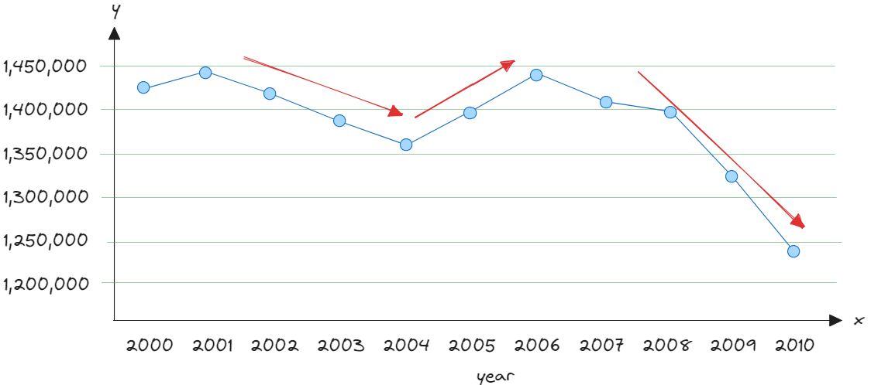

Crime decreased between 2001 and 2004, increased between 2004 and 2007, then decreased steadily from 2007 to 2010.

|  |  |  |  |  |  |  |  |  |  |  |  |
| --- | --- | --- | --- | --- | --- | --- | --- | --- | --- | --- | --- |
| **10.** | **Reasons We Travel**  The following data are based on a survey from American Travel Survey on why people travel. Construct a pie graph for the data and analyze the results.   |  |  | | --- | --- | | **Purpose** | **Number** | | Personal business | 146 | | Visit friends or relatives | 330 | | Work-related | 225 | | Leisure (休閒) | 299 | |

|  |  |  |  |  |
| --- | --- | --- | --- | --- |
| **Purpose** | **Number** | **%=f/n*100** | **Degrees=f/n*360** |  |
| Personal business | 146 | 14.6% | 52.56 $°$ |
| Visit friends or relatives | 330 | 33% | 118.8 $°$ |
| Work-related | 225 | 22.5% | 81 $°$ |
| Leisure | 299 | 29.9% | 107.64 $°$ |
| Total | 1000 | 100% | 360 $°$ |

About $\frac{1}{3}$ of the travelers visit friends or relatives, with the fewest travelling for personal business.

|  |  |  |  |  |  |  |  |  |  |  |  |  |  |  |  |  |  |  |  |  |  |  |  |  |  |  |  |  |  |  |  |  |  |  |  |  |  |  |  |  |  |  |  |  |  |  |  |  |  |
| --- | --- | --- | --- | --- | --- | --- | --- | --- | --- | --- | --- | --- | --- | --- | --- | --- | --- | --- | --- | --- | --- | --- | --- | --- | --- | --- | --- | --- | --- | --- | --- | --- | --- | --- | --- | --- | --- | --- | --- | --- | --- | --- | --- | --- | --- | --- | --- | --- | --- |
| **17.** | **50 Home Run Club**  There are 43 Major League (大聯盟) baseball players (as of (截至) 2015) that have hit 50 or more home runs in one season. Construct a stem and leaf plot and analyze the data.   |  |  |  |  |  |  |  |  | | --- | --- | --- | --- | --- | --- | --- | --- | | 50 | 51 | 52 | 54 | 59 | 51 | 53 | 54 | | 50 | 58 | 51 | 54 | 53 | 56 | 58 | 56 | | 70 | 54 | 52 | 58 | 54 | 64 | 52 | 73 | | 57 | 50 | 60 | 56 | 50 | 66 | 54 | 52 | | 51 | 58 | 63 | 57 | 52 | 51 | 50 | 61 | | 52 | 65 | 50 |  |  |  |  |  | |

|  |  |
| --- | --- |
| 5 | 0 0 0 0 0 0 1 1 1 1 1 2 2 2 2 2 2 3 3 4 4 4 4 4 4 |
| 5 | 6 6 6 7 7 8 8 8 8 9 |
| 6 | 0 1 3 4 |
| 6 | 5 6 |
| 7 | 0 3 |

Most players in the club have hit 50 to 54 home runs in one season. The maximum number of home runs hit is 73.

|  |  |  |  |  |  |  |  |  |  |  |  |  |  |  |  |  |  |  |  |  |  |  |  |  |  |  |  |  |  |  |  |  |  |  |  |  |  |  |  |  |  |  |  |  |  |  |  |  |  |  |  |  |  |  |  |  |  |  |  |  |  |
| --- | --- | --- | --- | --- | --- | --- | --- | --- | --- | --- | --- | --- | --- | --- | --- | --- | --- | --- | --- | --- | --- | --- | --- | --- | --- | --- | --- | --- | --- | --- | --- | --- | --- | --- | --- | --- | --- | --- | --- | --- | --- | --- | --- | --- | --- | --- | --- | --- | --- | --- | --- | --- | --- | --- | --- | --- | --- | --- | --- | --- | --- |
| **19.** | **Length of Major Rivers**  The data show the lengths (in hundreds of miles) of major rivers in South America and Europe. Construct a back-to-back stem and leaf plot, and compare the distributions.   |  |  |  |  |  |  |  |  |  |  | | --- | --- | --- | --- | --- | --- | --- | --- | --- | --- | | **South America** | | | | | **Europe** | | | | | | 39 | 21 | 10 | 10 | 11 | 5 | 12 | 7 | 6 | 8 | | 10 | 2 | 10 | 10 | 14 | 5 | 5 | 4 | 6 | 18 | | 10 | 12 | 17 | 15 | 10 | 5 | 13 | 9 | 14 | 6 | | 15 | 25 | 16 |  |  | 6 | 11 | 8 | 6 | 3 | |  |  |  |  |  | 4 |  |  |  |  | |

|  |  |  |  |
| --- | --- | --- | --- |
| **South America** |  | **Europe** |  |
| 2 | 0 | 3 4 4 |  |
|  | 0 | 5 5 5 5 6 6 6 6 6 7 8 8 9 |  |
| 4 2 1 0 0 0 0 0 0 0 | 1 | 1 2 3 4 |  |
| 7 6 5 5 | 1 | 8 |  |
| 1 | 2 |  |  |
| 5 | 2 |  |  |
|  | 3 |  |  |
| 9 | 3 |  |  |

The majority of rivers are longer in South America.

|  |  |
| --- | --- |
| **22.** | State which graph (Pareto chart, time series graph, or pie graph) would most appropriately represent the given situation.   1. The number of students enrolled at a local college for each year during the last 5 years   (過去5年每年本地大學註冊的學生人數)   1. The budget for the student activities department at a certain college for a specific year   (某個大學學生活動部門特定年份的預算)   1. The means (手段;方法) of transportation the students use to get to school   (學生上學所使用的交通工具)   1. The percentage of votes each of the four candidates received in the last election   (四位候選人在上次選舉中獲得的選票百分比)   1. The record temperatures of a city for the last 30 years   (一座城市過去30年的最高氣溫紀錄)   1. The frequency of each type of crime committed in a city during the year   (一座城市一年內各類犯罪的頻率) |

1. Time series graph
2. Pie graph (預算是固定的，所以不在意它實際花多少，比較在意都花在哪)
3. Pareto chart
4. Pie graph
5. Time series graph
6. Pareto graph

|  |  |  |  |  |  |  |  |  |  |  |  |  |  |  |  |  |  |  |  |
| --- | --- | --- | --- | --- | --- | --- | --- | --- | --- | --- | --- | --- | --- | --- | --- | --- | --- | --- | --- |
| **27.** | **Chicago Homicides**  Draw and compare two time series graphs for the number of homicides (凶殺案) in the Chicago area.   |  |  |  | | --- | --- | --- | | **Year** | **Homicides** | **As of June 29** | | 2005 | 451 | 207 | | 2007 | 448 | 204 | | 2009 | 459 | 204 | | 2011 | 435 | 187 | | 2013 | 414 | 180 | |

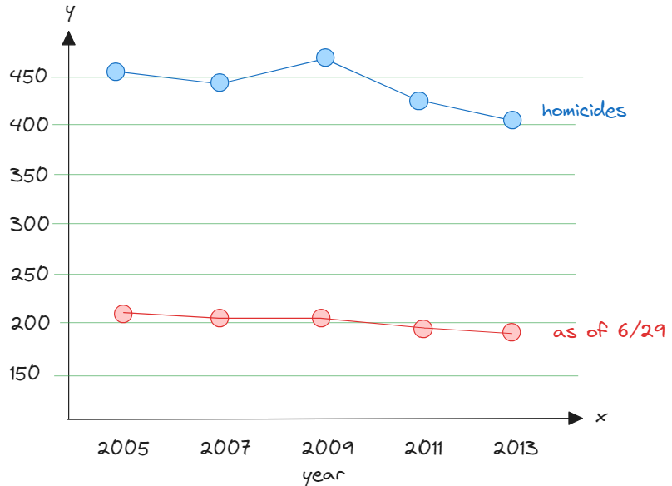

There is no way to tell if the crime rate is decreasing by looking at the graph.

***Sec. 2-4 (p.102)***

|  |  |  |  |  |  |  |  |  |  |  |  |  |  |  |  |  |  |  |  |  |  |  |  |
| --- | --- | --- | --- | --- | --- | --- | --- | --- | --- | --- | --- | --- | --- | --- | --- | --- | --- | --- | --- | --- | --- | --- | --- |
| **8.** | **Employee Absences**  A researcher wishes to determine if there is a relationship between the number of days an employee missed a year and the person's age. Draw a scatter plot and comment on the nature of the relationship.   |  |  |  |  |  |  |  |  |  |  |  | | --- | --- | --- | --- | --- | --- | --- | --- | --- | --- | --- | | Age, x | 22 | 30 | 25 | 35 | 65 | 50 | 27 | 53 | 42 | 58 | | Days Missed, y | 0 | 4 | 1 | 2 | 14 | 7 | 3 | 8 | 6 | 4 | |

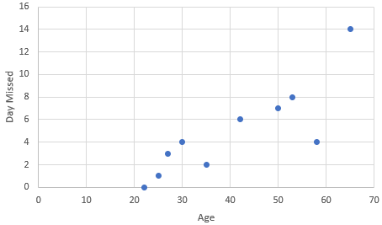

There appears to be positive linear relationship between an employee’s age and the number of days missed per year.

|  |  |  |  |  |  |  |  |  |  |  |  |  |  |  |  |
| --- | --- | --- | --- | --- | --- | --- | --- | --- | --- | --- | --- | --- | --- | --- | --- |
| **13.** | **Absences and Final Grades**  An educator wants to see if there is a relationship between the number of absences a student has and his or her final grade in a course. Draw a scatter plot and comment on the nature of the relationship.   |  |  |  |  |  |  |  | | --- | --- | --- | --- | --- | --- | --- | | Numeber of abscences, x | 10 | 12 | 2 | 0 | 8 | 5 | | Final grade, y | 70 | 65 | 96 | 94 | 75 | 82 | |

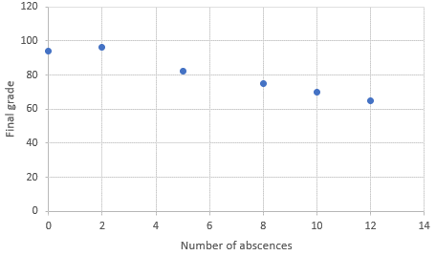

There appears to be a negative linear relationship between the number of abscences and student’s final grade in a course.